**Listening as an essential part of emotional intelligence and interpersonal skills**

Numerous studies (summarized in Flynn et al., 2008) find listening to be the most important communication skill for entry-level workers, subordinates, supervisors, and managers on several dimensions: job and career success, productivity, upward mobility, communication training, and organizational effectiveness. Moreover, people who work in organizations that value listening to their employees have a stronger sense of attachment and loyalty to their companies (Reed et al., 2016).

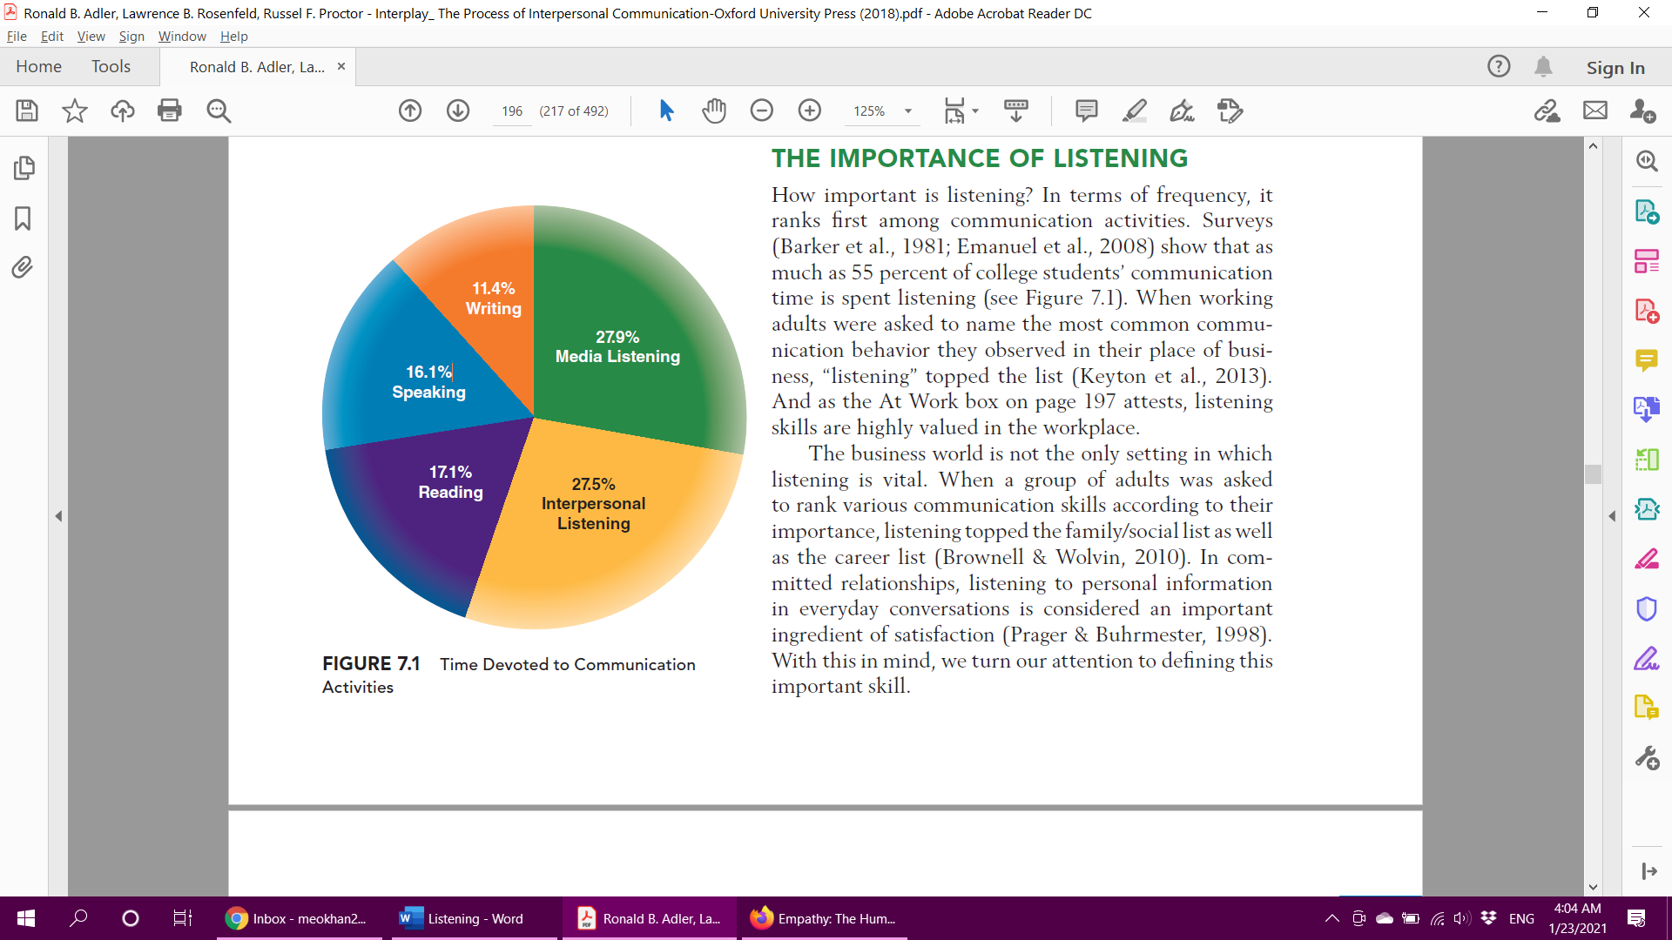

**Hearing Versus Listening**

Listening and hearing aren’t identical. Hearing is the process in which sound waves strike the eardrum and cause vibrations that are transmitted to the brain. Listening occurs when the brain reconstructs these electrochemical impulses into a representation of the original sound and then gives them meaning (Robinshaw, 2007).

**Mindless listening** occurs when we react to others’ messages automatically and routinely, without much mental investment.

**Mindful listening** involves giving careful and thoughtful attention and responses to the messages we receive.

**Listening Styles**

**Task-oriented listening:** focus on the task at hand – usually at the expense of emotions

**Relational listening:** Building relations and emotions (extroverts, friendly, attentive, empathic)

**Analytical listening** emphasizes attending to the full message before coming to judgment.

**Critical listening:** assessing their quality, focusing on accuracy and consistency (investigative but frustrating for others).

***(Physiological factors, social roles, cultural background, personal interests all play a role in how we might listen to others)***

**Avoiding poor listening habits**

* **Pseudolistening** is pretending to pay attention. Pseudolisteners look others in the eye, and they may even nod and smile, but their minds are in another world.
* **Stage hogging** is expressing your own ideas without inviting others to share theirs. Stage hogs allow others to speak from time to time, but only so they can catch their breath; they do not seem to care what others may contribute to the conversation.
* **Selective listening** is responding only to the parts of a speaker’s remarks that interest you, ignoring or rejecting everything else. *(badly needed skill today)*
* **Filling in gaps** is manufacturing information that wasn’t part of an original story or message. When people who fill in gaps retell what they listened to, they present a distorted (not merely incomplete) version of the original.
* **Insulated listening** is almost the opposite of selective listening. Instead of focusing only on topics of interest, these listeners tune out any topics they’d rather not deal with.
* **Defensive listening** is taking innocent comments as personal attacks. Defensive listeners project their own insecurities onto others.
* **Ambushing is** listening carefully only to collect information for use in attacking the speaker. This kind of strategy can ruin a supportive communication climate.

**Components of listening**

Hearing ► Attending ► Understanding ► Remembering ► Responding

**Types of listening responses**

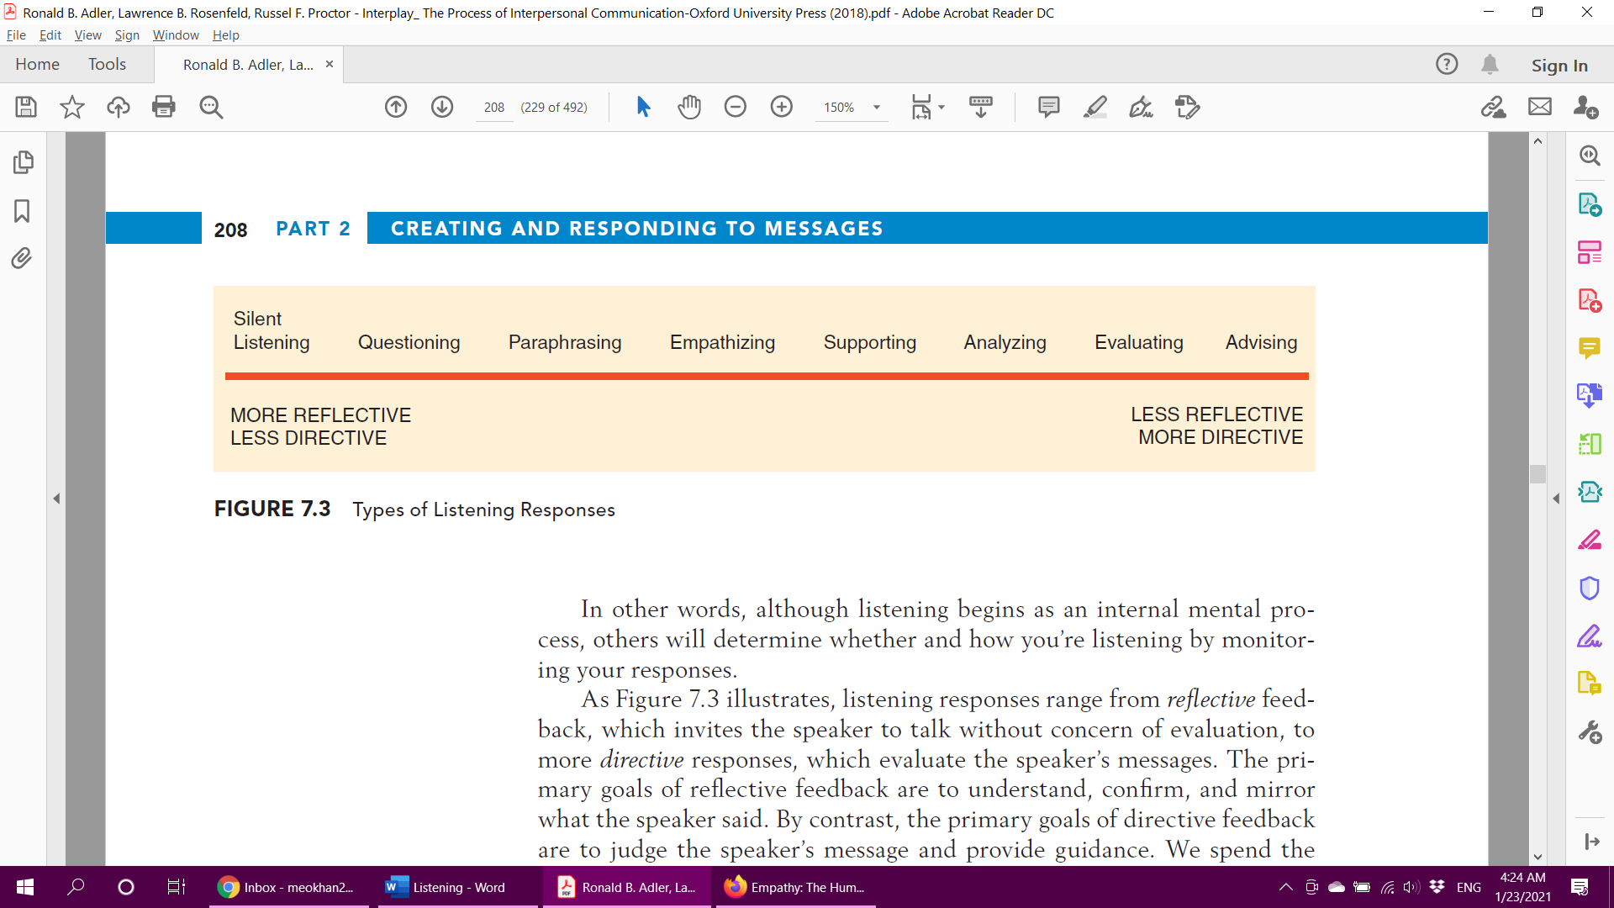

**Silent listening** – the gold standard missing in today’s world.

**Questioning**

* To clarify meanings: *“You said you were going ‘fast’—just how fast were you going?”*
* To learn about others’ thoughts, feelings, and wants: *“How did you feel?”* open-ended verses close question, *“Did you feel angry?”*
* To encourage elaboration: *“Tell me more about it”*

**Avoid counterfeit questions, *“Are you finally ready?”, “You said you’d call at 5, but you forgot, didn’t you?”* They tend to trap the speaker, send a message.**

**Paraphrasing** (not parrot-phrasing)

* “Let’s make plans for next weekend.”
* “So you want to chat next week to make plans for Saturday?”
* For personal information
* Factual information

**Empathizing**

“I can see that really hurts.”

“I know how important that was to you.”

“This means a lot to you, doesn’t it?”

**Avoid**

* Denying others the right to feelings (don’t worry about it).
* Minimizing the significance of the situation (c’mon, it was just a game!)
* Focus on yourself (I know. Let me tell you)

**Supporting** *responses that reveal the listener’s solidarity with the speaker’s situation.*

* **Agreement** “Yeah, that class was tough for me too.” “You’re right—the landlord is being unfair.”
* **Offers to help** “I’m here if you need me.” “Let me try to explain it to him.”
* **Praise** “I don’t care what the boss said: I think you did a great job!”

“You’re a terrific person! If she doesn’t recognize it, that’s her problem.”

* **Reassurance** “The worst part seems to be over. It will probably get easier from here.”

“You’ve got this.”

* **Diversion** “Let’s catch a movie and get your mind off this.” “That reminds me of the time we . . .”

**Analyzing**

In analyzing a situation, the listener offers an interpretation of a speaker’s message (“I think what’s really bothering you is . . .”; “She’s doing it because . . .”; or “Maybe the problem started when he . . .”).

**Evaluating**

An evaluating response appraises the sender’s thoughts or behaviors in

some way. The evaluation may be favorable (“That’s a good idea” or “You’re

on the right track now”) or unfavorable (“An attitude like that won’t get

you anywhere”).

***Both parts of critical listening***

**Advising**

• **Is the advice needed?** If the person has already taken a course of action, giving advice after the fact (“I can’t believe you got back together with him”) is rarely appreciated.

• **Is the advice wanted?** People generally don’t value unsolicited advice. It’s usually best to ask if the speaker is interested in hearing your counsel. Remember

that sometimes people just want a listening ear, not solutions to their problems.

• **Is the advice given in the right sequence?** Advice is more likely to be received after the listener first offers empathizing, paraphrasing, and questioning responses to understand the speaker and the situation better.

**• Is the advice coming from an expert?** If you want to offer advice about anything from car purchasing to relationship managing, it’s important to have experience and success in those matters. If you don’t have expertise, it’s a good idea to offer the speaker supportive responses, then encourage the person to seek out expert counsel.

**• Is the advisor a close and trusted person?** Although sometimes we seek out advice from people we don’t know well (perhaps because they have expertise), in most cases we value advice given within the context of a close and ongoing interpersonal relationship.

• **Is the advice offered in a sensitive, face-saving manner?** No one likes to feel bossed or belittled, even if the advice is good (Miczo & Burgoon, 2008). Remember that messages have both content and relational dimensions. Sometimes the unstated relational messages when giving advice (“I’m smarter than you”; “You’re not

bright enough to figure this out yourself ”) will keep people from hearing counsel.

**Reference**

Adler, R. B., Rosenfeld, L. B., Towne, N., & Scott, M. (2018). *Interplay: The process of interpersonal communication*.